Verify Check  Cab  Cleanliness  Seat  Operator restraint  Instruments & labeling  Levers / Controls  Pedals  Protective mesh  Rear view mirrors  ROPS to AS 2294  Operator instructions  (available on plant) | Supplier verification & Plant details
 | Plant owner:
Verify Check  Warning signs (in cabin)  SEAT BELTS MUST BE WORN  Verify Check  DANGER – BEWARE OVERHEAD WIRES  & UNDERGROUND SERVICES | Address:
 | City/Suburb:
 | Phone:
 | Plant make:
Verify Check  Exhaust  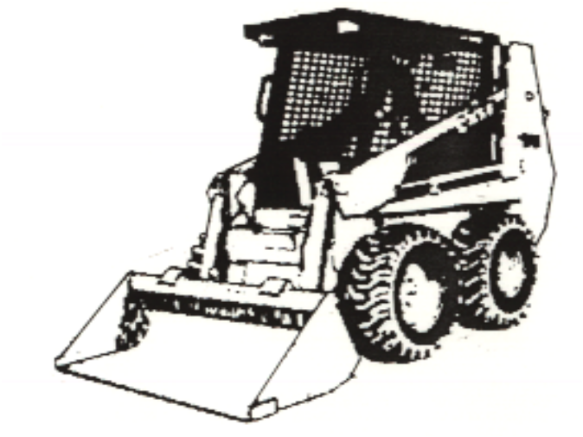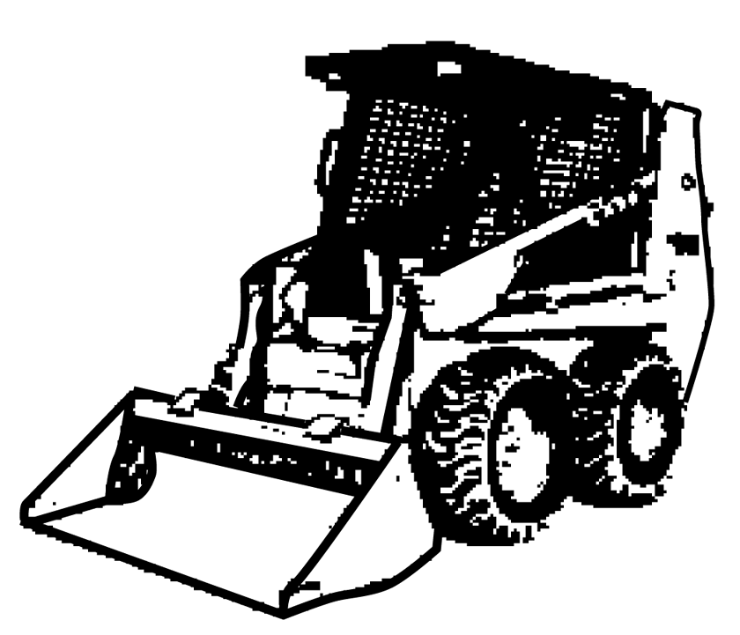 | Plant model:
Verify Check  Engine guarding  Verify Check  Hydraulics  Rams  Hoses  Connections  (check for excessive wear, leaks and creep) | Serial no.:
 | Signature:
Verify Check  Pivots  Connecting rods  Safety pins  (no excessive wear) | Date:
 | WorkCover Certification - LS
Verify Check  Rams  Hoses  Connections  (check for excessive wear, leaks and creep)  Hydraulics |  Plant to conform to manufacturer’s specifications and Plant Regulations.   Plant operator is to provide daily checksheets to WDA on a weekly basis   Where applicable, Personal Protective Equipment must be worn.   Plant Log Book detailing service history in accordance with Manufacturer’s specifications should be written legibly in English.   Contractor must produce proof of competence of operator, e.g., Certificate of Competence, Licence, detailed Log Book
Verify Check  Tyres  Wheels  Brakes  Park brake | WDA use only
Verify Check  SWL / Crane chart | Note: Sign only when all items have been checked
 | Plant check by:
Instructions:  Verify Box to be ticked by Owner / Supplier / Operator prior to arrival onsite.  Check Box to be ticked after visual inspection by MACDDOW | Position:
 | Date: |  | / /

